**Project Design Phase-II**

**Data Flow Diagram & User Stories**

|  |  |
| --- | --- |
| Date | 31 October 2022 |
| Team ID | PNT2022TMID05193 |
| Project Name | Project – Smart Waste Management |
| Maximum Marks | 4 Marks |

# Data Flow Diagrams:

A Data Flow Diagram (DFD) is a traditional visual representation of the information flows within a system. A neat and clear DFD can depict the right amount of the system requirement graphically. It shows how data enters and leaves the system, what changes the information, and where data is stored.

# Flow Diagram:

Our waste generation is constantly growing to form a **global garbage crisis**. Even though we indulge in creating a more sustainable and greener, we still fail to handle our waste generation and management. Combining technology support with a vision of social, economical and environmental sustainability is the best way out of this problem. It is done in the following manner:

1. The smart bin system undergoes a thorough system check in order to function efficiently.
2. The threshold level levels of the bin are indicated my multiple sensors attached to bin. If the garbage exceeds the level, then an alert message is sent to the garbage collectors as well as to the municipality or area administration.
3. The area in which garbage is found to overflow is allocated to respective garbage collectors in the form of messages through GSM system.
4. Once the waste bin is emptied, an information update is sent to the municipality and server is updated.

This is how the waste from bins can be efficiently handled and managed using technology which in turn keeps the environment clean and healthy.

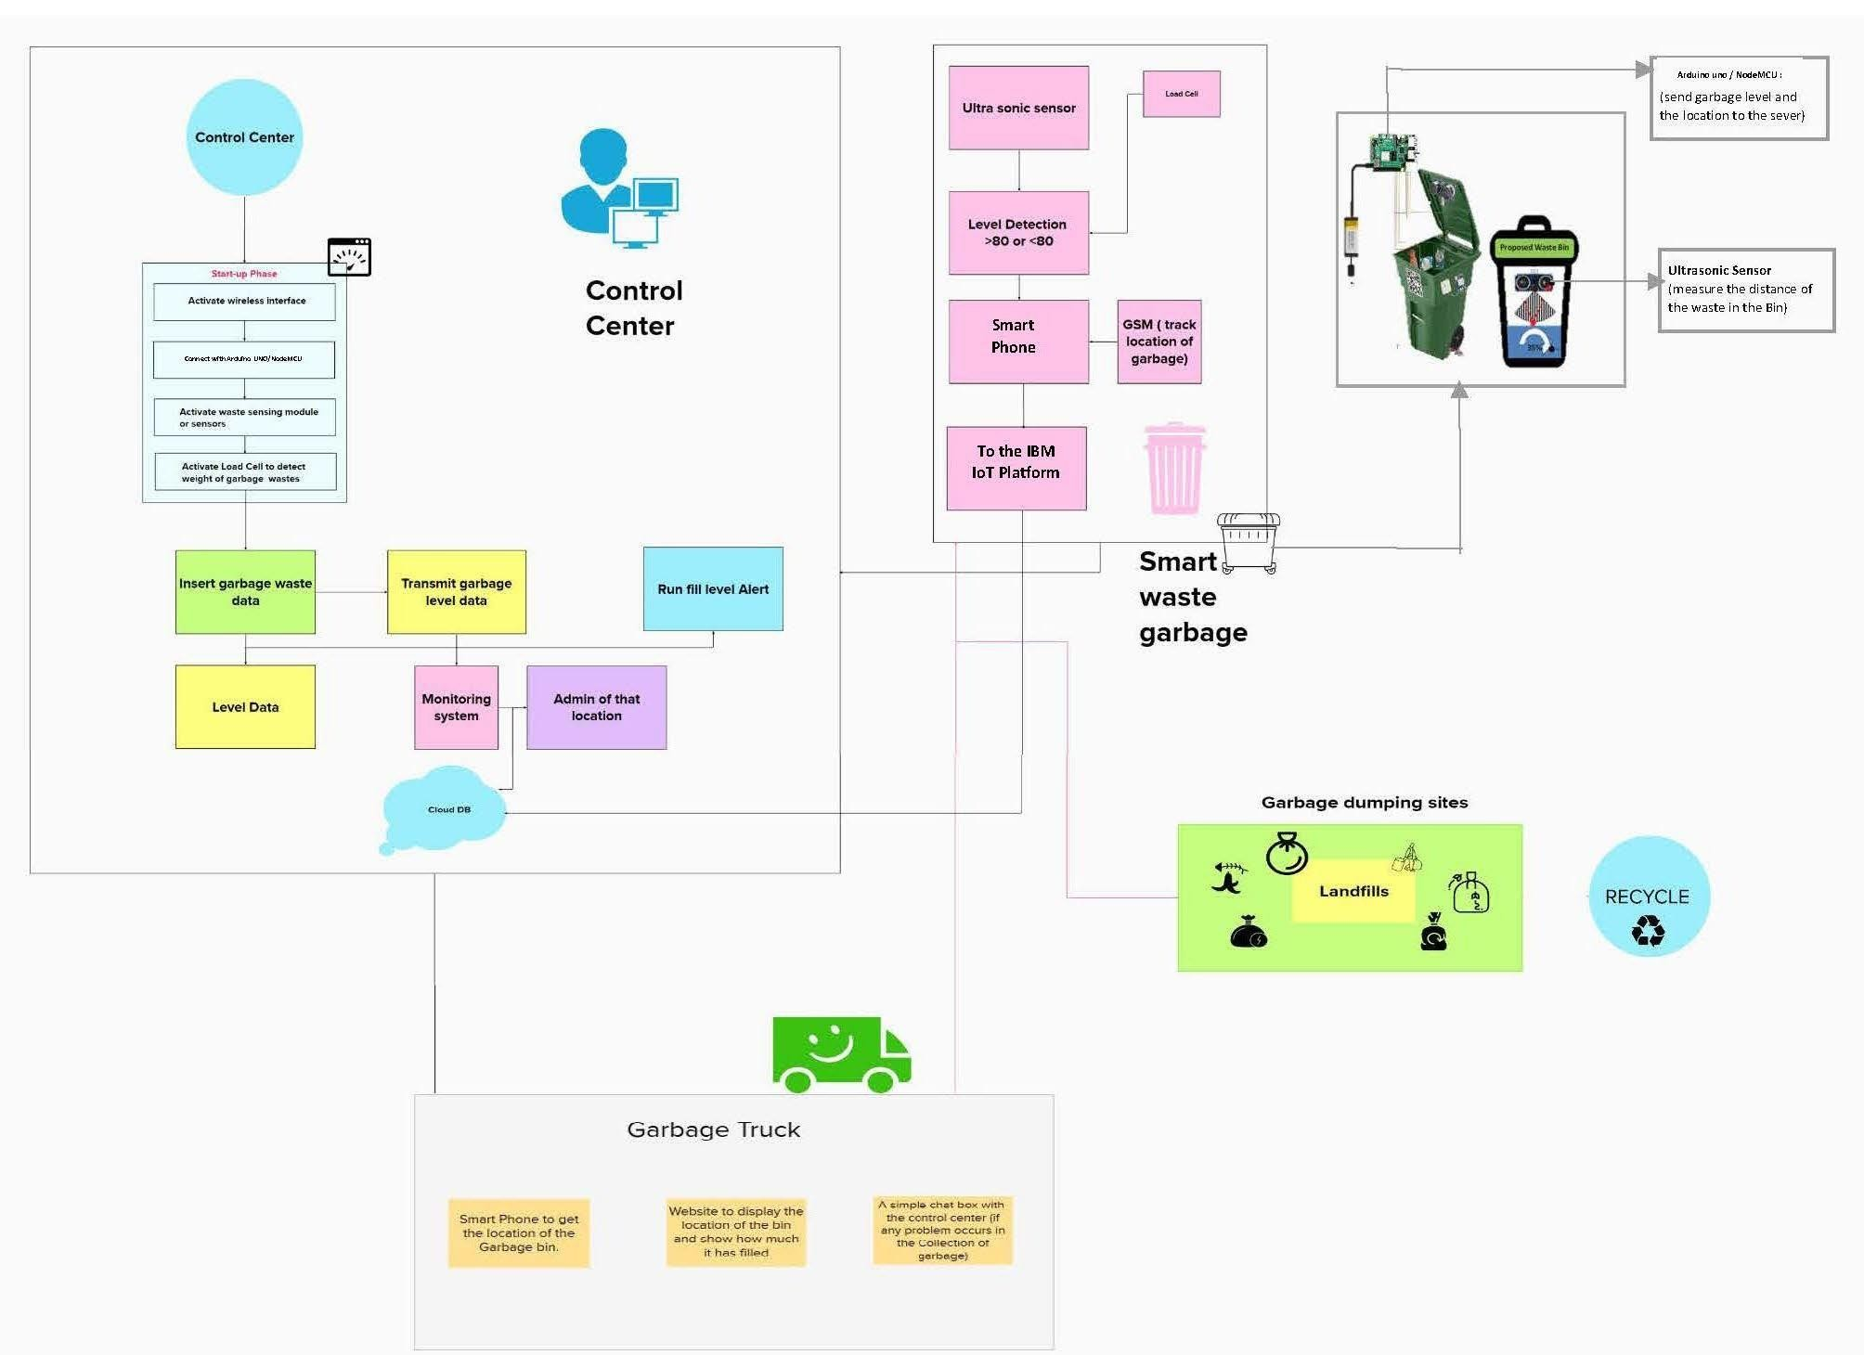

**User Stories:**

|  |  |  |  |  |  |  |
| --- | --- | --- | --- | --- | --- | --- |
| **User Type** | **Functional Requirement (Epic)** | **User Story Number** | **User Story / Task** | **Acceptance criteria** | **Priority** | **Release** |
| Admin (Corporate Authority) | Login | USN-1 | As an administrator, I have assigned user names and passwords to each employee and add new dustbins and their location and  send mail to Truck Driver when the location is filled | I can manage my online account and dashboard. | Medium | Sprint-2 |
| Truck Driver | Login | USN-2 | As a Truck Driver, I'll follow Admin’s instruction and the route assigned to reach the filled garbage. | I can take the shortest path assigned to me and reach the waste filled land. | Medium | Sprint-2 |
| Local Garbage Collector | Login | USN-3 | As a Local Garbage Collector, I’II gather all the waste collected from the garbage and house and load it onto a garbage truck. | I can collect the waste, pull it to the truck, and send it out. | Medium | Sprint-2 |
| Municipality officer | Login | USN-4 | As a Municipality officer, I'll make sure everything is sticked to plan and without any issues. | All of these processes are under my control. | High | Sprint-1 |